Langenburg Central School

School Community Council

Meeting Minutes
May 10, 2022
Call to order
Jenay Werle called the meeting to order at 7:00 pm.

In Attendance
The following persons were present: Kim Wondrasek, Raelene Andres, Jenay Werle, Brandon Needham, Michelle Andrews. Jill Faul, Tracy Olson, Tim Kempton, Grace Ungrin, Lois Smandych, Deb Kutvonen & Daniella Lenz
Adoption of Agenda
Kim W motioned to approve agenda as presented. Tim seconded. /Carried

Approval of minutes from last meeting
Discussion of the minutes from the last meeting. Deb motioned to approve minutes as presented Kim W seconded. /Carried

Principal’s Report

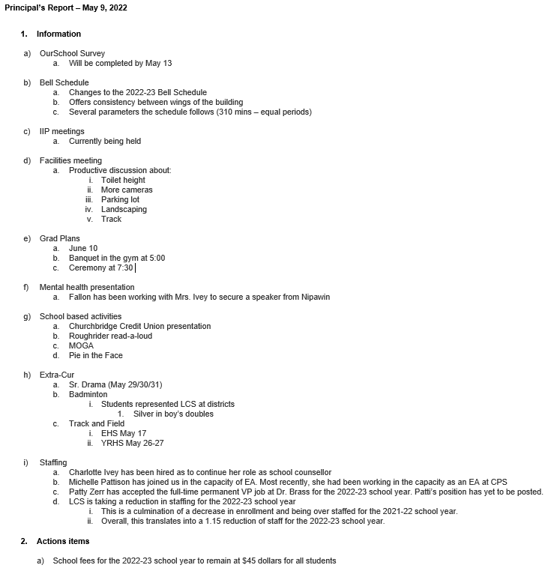

Kim made a motion to approve the school fees at $45. Michelle seconded. / Carried
Raelene motioned to approve the report as presented Jill seconded. /Carried

Treasurer’s Report

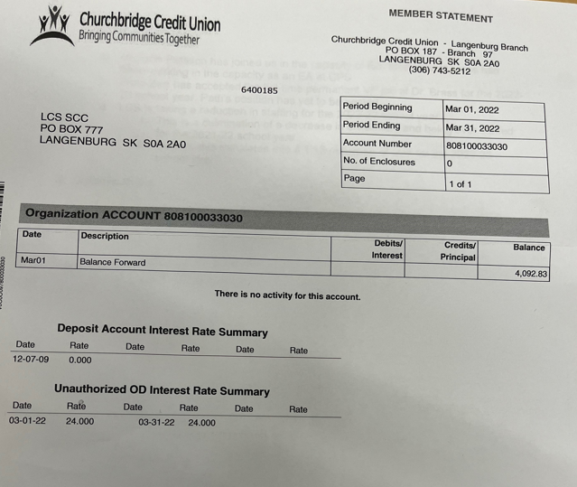
Balance of $4092.83 * Payment of $1000 for Mental Health Speaker and Babysitting fees still need to be paid.

Kim W motioned to approve this report as presented Rae seconded. /Carried

Old Business:
- Mental Health Presentation – Fallon has a speaker lined up
- SCC Champion Award – Jill met with Sheldon and explained the intentions of this award. A name will be given to the SCC by the end of May 2022.

New Business:
- SCC Symposium – Tim did up a summary
- 2022-23 Welcome Back breakfast – SCC is all in favor of going ahead with the pancake breakfast. Jill will order the supplies, Jenay will touch base mid-August to set a date and get members signed up to help.
- Canteen for Track & Field – LCS staff has the canteen taken care of.
- Sympathy gift for the Parmar family/Going away gift for Mick
- Deb made a motion to contribute $100 to the Parmar family to be combined with the LCS staff’s contribution to go towards meals. Jill seconded/carried.
- Jill made a motion to spend $150 (prairie proud swag) to be given to Mick at the June 27th assembly as a going away gift from the SCC. Kim W seconded/carried.

2021/2022 Meeting Dates
January 10, 2022 – Postponed to February 7, 2022
March 14, 2022
May 9, 2022
September 12, 2022
November 14, 2022

Adjournment
Jenay Werle adjourned the meeting at 8:30 pm.
Minutes submitted by: Raelene Andres
Minutes approved by: Kim Apland

