Langenburg Central School

School Community Council

Meeting Minutes
May 15, 2023
Call to order
Jenay Werle called the meeting to order at 6:59pm.

In Attendance
The following persons were present: Mandi Kobylko, Tracy Olson, Kim Apland, Jill Faul, Lana Bily, Fallon Prince, Brandon Needham, Oralee DeCorby, Jenay Werle, Lois Smandych (virtually)
Adoption of Agenda
Jill motioned to approve agenda as presented. Kim A seconded. /Carried

Approval of minutes from last meeting
Motion to formally appoint Kim Apland, Mandi Kobylko and Lana Bily (made vie email) by Raelene Andres on March 22, 2023. Michelle seconded. / Carried.

Principal’s Report

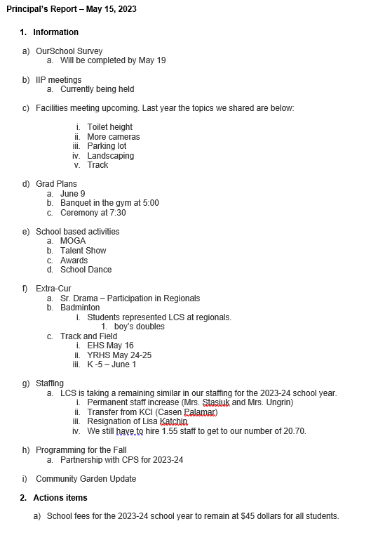

Lana motioned to approve the report as presented Jill seconded. /Carried

Treasurer’s Report

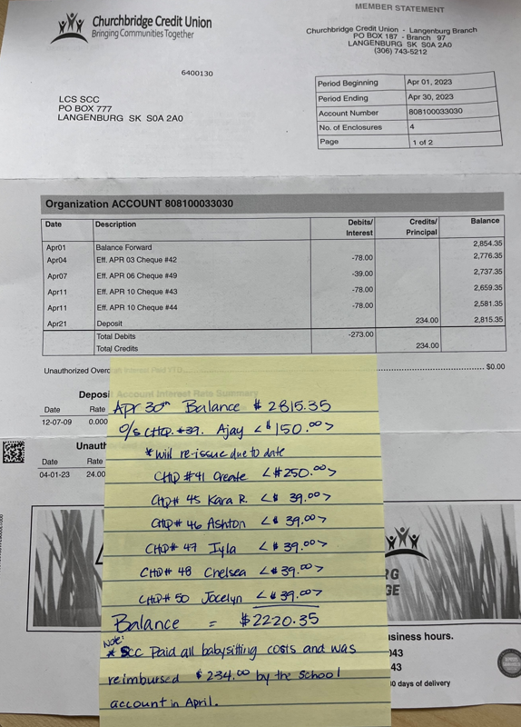

Jill motioned to approve this report as presented Kim A seconded. /Carried

Old Business:
- GSSD Training Modules for SCCs – discussed the feedback from members.
- SCC Symposium – next session is on June 6 (unpacking the budget).
- SCC Scholarship – Jill recapped the intent of the “Community Champion” award. The LCS scholarship committee will be tasked with selecting a winner.

New Business:
- Make up date for March meeting – not necessary
- LCS Garden project
- The land won’t be ready this year so they’ll start instead with a composting project. There will be a composting pail in each classroom. The project will be able to access a $500 grant to get started.

2022/2023 Meeting Dates
November 14, 2022
January 9, 2023
March 20, 2023
May 15, 2023
September 11, 2023
November 13, 2023

Adjournment
Jenay Werle adjourned the meeting at 8:27 pm.
Minutes submitted by: Jenay Werle
Minutes approved by: Jill Faul

