Langenburg Central School

School Community Council

Meeting Minutes
November 8, 2021
Call to order
Jenay Werle called the meeting to order at 7:28 pm.

In Attendance
The following persons were present: Kim Wondrasek, Raelene Andres, Jenay Werle, Tim Kempton, Brandon Needham, Fallon Prince, Michelle Andrews, Tracy Olson, Lois Smandych, Deb Kutvonen, Grace Ungrin, Danielle Lenz, Colleen Waldherr & Erin Schnee
Adoption of Agenda
Kim W motioned to approve agenda as presented. Jill seconded. /Carried

Approval of minutes from last meeting
Discussion of the minutes from the last meeting. Tim motioned to approve minutes as presented Raelene seconded. /Carried

Principal’s Report
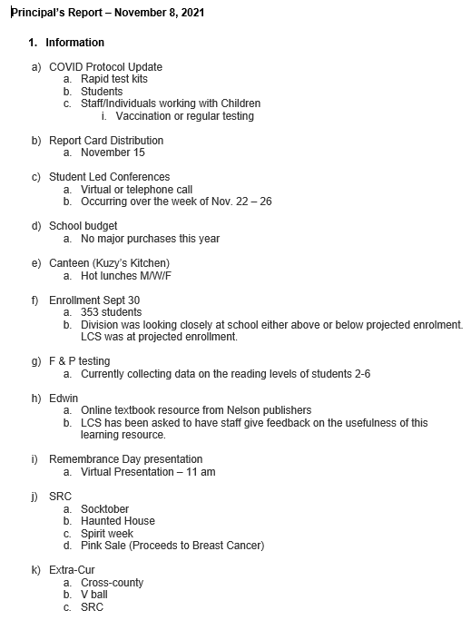
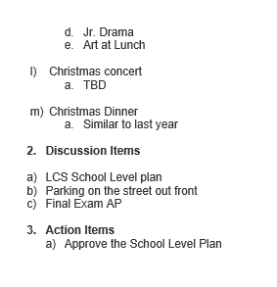
Kim W motioned to approve the report as presented Jill seconded. /Carried

Treasurer’s Report

Ending balance $2613.80
Raelene motioned to approve this report as presented Jill seconded. /Carried

Old Business:
- SCC Initiatives for Discussion
  - Presentation from ICE unit – Fallon looking into presentation with RCMP
  - Presentation on drugs and alcohol use
  - Brainstorming – Social Media speaker, Vaping speaker
- Christmas Dinner and talent show

New Business:
- Student Parking Lot Garbage – teachers will talk to students about this
- Repairs and Maintenance
- Stage doors- have been fixed,
- Outdoor rink light – Brandon will look into how lights are controlled, and light will get fixed
- Kitchen cooler – has been fixed
- PAC Elections -more communication will be sent out, so parents are notified and aware of what the process is.

2021/2022 Meeting Dates

Regular Meeting & AGM November 8, 2021
January 10, 2022
March 14, 2022
May 9, 2022
September 12, 2022
November 14, 2022

Adjournment
Jenay Werle adjourned the meeting at 8:37 pm.
Minutes submitted by: Raelene Andres
Minutes approved by: Kim A

