Langenburg Central School

School Community Council

Meeting Minutes
March 14, 2022
Call to order
Jenay Werle called the meeting to order at 7:00 pm.

In Attendance
The following persons were present: Kim Wondrasek, Raelene Andres, Jenay Werle, Fallon Prince, Michelle Andrews. Jill Faul, Tracy Olson, Lois Smandych (virtual), Deb Kutvonen, & Erin Schnee
Adoption of Agenda
Deb motioned to approve agenda as presented. Kim W seconded. /Carried

Approval of minutes from last meeting
Discussion of the minutes from the last meeting. Jill motioned to approve minutes as presented Kim A seconded. /Carried

Principal’s Report
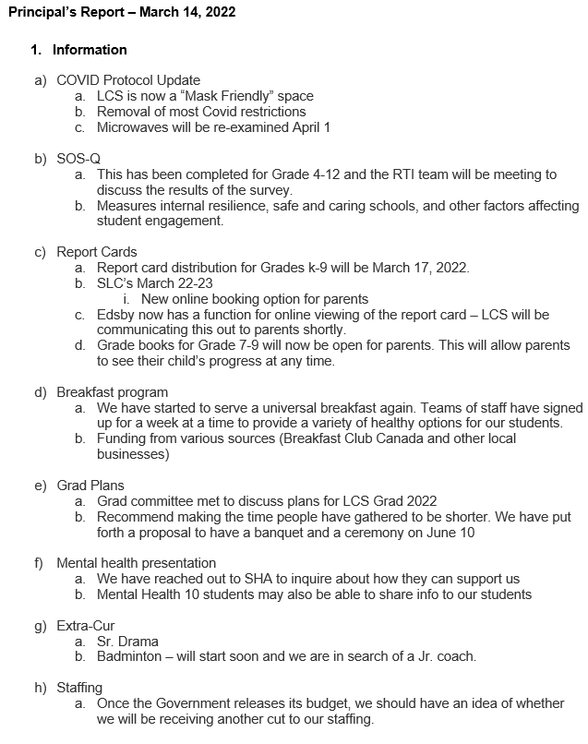

Raelene motioned to approve the report as presented Kim W seconded. /Carried

Treasurer’s Report

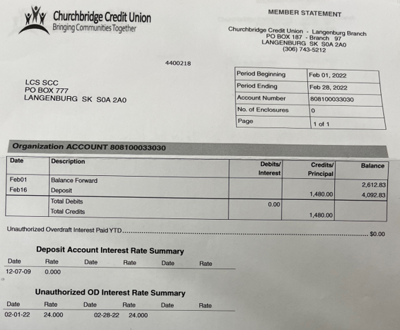
Jill motioned to approve this report as presented Kim A seconded. /Carried

Old Business:
- Mental Health Presentation – Michelle made a motion to spend up to $1,000.00 for a mental health speaker. Jill seconded/carried

New Business:
- SCC Scholarship – Jill to meet with Sheldon Kaminski to tweak the form
Rae made a motion to provide $150 donation for SCC Champion award Kim W seconded/ carried
- Mosaic EHS – May 9th Esterhazy Boreen Centre. Open to the public
- Ski Trip - some parent expressed concern about not having the choice to go this year. The board encourages these parents to reach out to the school if they would like to help organize.
- SLC’s – Kim W made a motion to pay ½ wages for 4 students to babysit in the gym during SLC’s. Michelle seconded/ carried.

2021/2022 Meeting Dates

Regular Meeting & AGM November 8, 2021
January 10, 2022
March 14, 2022
May 9, 2022
September 12, 2022
November 14, 2022

Adjournment
Jenay Werle adjourned the meeting at 7:52 pm.
Minutes submitted by: Raelene Andres
Minutes approved by: Kim W

