Langenburg Central School

School Community Council

AGM Meeting Minutes
November 14, 2022
- Call to order
Jenay Werle called the meeting to order at 7:00pm.

- In Attendance
The following persons were present: Kim Wondrasek, Raelene Andres, Jenay Werle, Tim Kempton, Jill Faul, Brandon Needham, Fallon Prince, Michelle Andrews, Tracy Olson, Deb Kutvonen, Avery Rosin, Danielle Lenz, Sonja Graff, Erin Schnee, Tristine Kohl & Luke Krienke

- Adoption of Agenda
Jill motioned to approve minutes as presented. Tim seconded. /Carried

- Principal’s Report
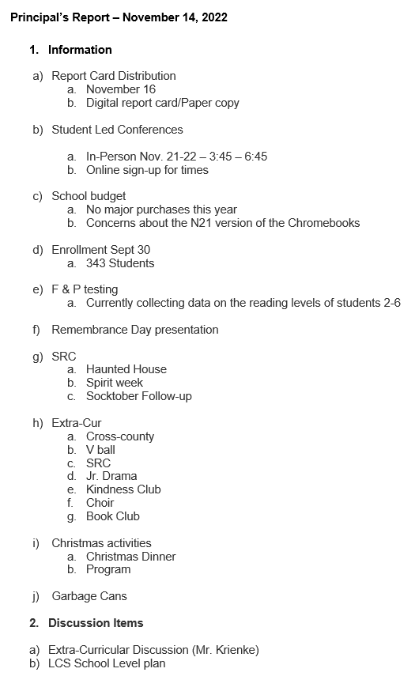

- Presentation of 2020/2021 Financial Report
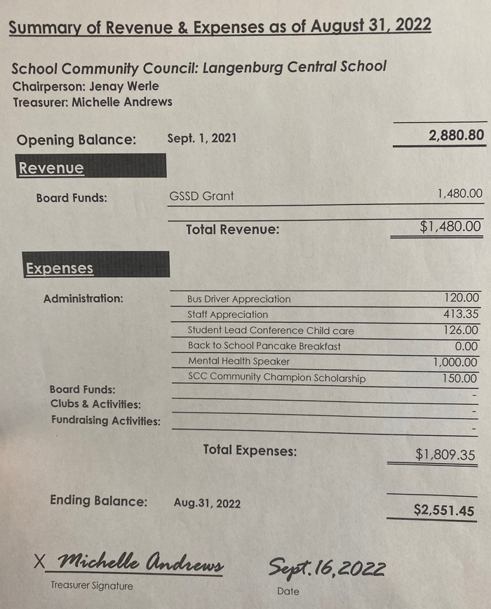

- New Business
- Election of Vacant Positions (2 year term/4 members per year)
2017 AGM filled by Kim Wondrasek (Vice President), Raelene, Tim and Ben
2018 AGM filled by Jenay, Michelle, Jill, Kim Apland (KimW assume chair following Lindsay Werle’s resignation)
2019 AGM positions filled by: Raelene, Tim (Jenay elected as Vice Chair)
2020 AGM positions filled by: 2year: Michelle, Jill, Kim Apland
1year: Deb, Erin
2021 AGM positions filled by: 2year:Kim W, Raelene, Deb (Jill elected as Vice Chair)
1 year: Tim
2022 positions: 3/2year positions - Michelle, Kim Apland (Jill automatically continues on as vice chair)
1/1 year position open as it currently is vacant following Deb Kutvonen’s resignation

Jenay opened nominations for the 3 - two year term positions. Raelene Nominated Michelle. She accepted
Jenay opened nominations for the 1 - one year term positions. Nobody accepted
Jenay called nominations cease.
All nominated people accepted their nominations and have agreed to serve their term.
- Election of Executive

Jenay opened the floor for nominations for Secretary. Jill Nominated Raelene. She accepted. Jenay moved nominations cease for Secretary.

Jenay opened the floor for nominations for Treasurer. Rae Nominated Michelle. She accepted. Jenay moved nominations cease for Treasurer.

- Next AGM Meeting Date: November 13, 2023 AT 7:00PM AT LCS
- Adjournment
Jenay Werle adjourned the meeting at 7:12 pm.
Minutes submitted by: Raelene Andres
Minutes approved by: Kim W

