Langenburg Central School

School Community Council

Meeting Minutes
November 6, 2023
- Call to order
Jill Faul called the meeting to order at 7:18 PM.

- In Attendance
The following persons were present: Tracey Olson, Raelene Andres, Kim Apland, Jill Faul, Lana Bily, Fallon Prince, Michelle Andrews, Jesse Burton-Sheppard, Oralie DeCorby, Jenay Werle, Lois Smandych, Kim Wondrasek, Mandi Kobylko, Melissa Ingjaldson, Deb Kutvonen, Danielle Lenz.

- Adoption of Agenda
Jenay motioned to approve agenda as presented. Raelene seconded. /Carried

- Approval of minutes from last meeting
Kim W. motioned to approve September 11, 2023 minutes. Michelle seconded. /Carried

- Principal’s Report
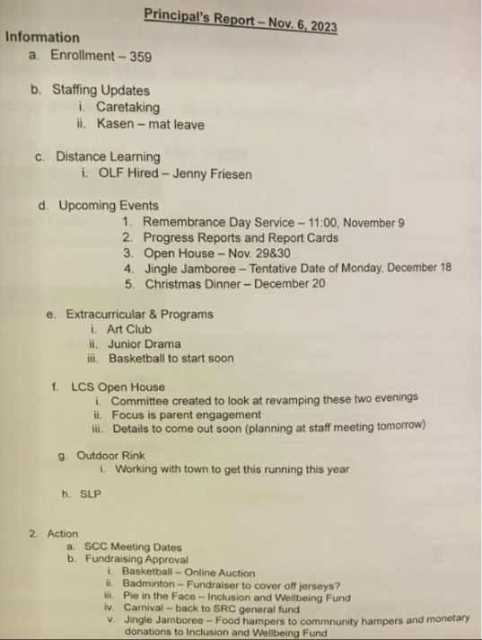

- Discussion on open house and parent interest in the importance of using this time to incorporate meeting times for parents to connect with teachers.
- The open house concept is to foster engagement and bring more families into the school, especially in the middle / senior years.
- Other schools have held an open house and the intent was to try it this year. Looking for a way to engage all families (traditional student led conferences bring in families in earlier grades, not grades 8+).
- Fallon will take this feedback to the November 7th staff meeting.

Raelene motioned to approve the report as presented. Kim A. seconded. /Carried

- Treasurer’s Report
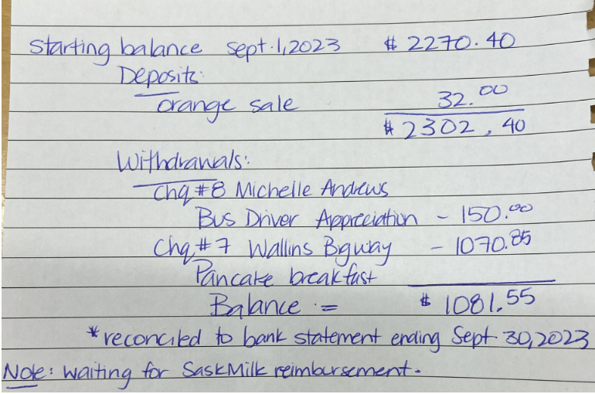

Lana motioned to approve this report as presented. Melissa seconded. /Carried

- Old Business:
- Welcome Back Breakfast 2023 Recap
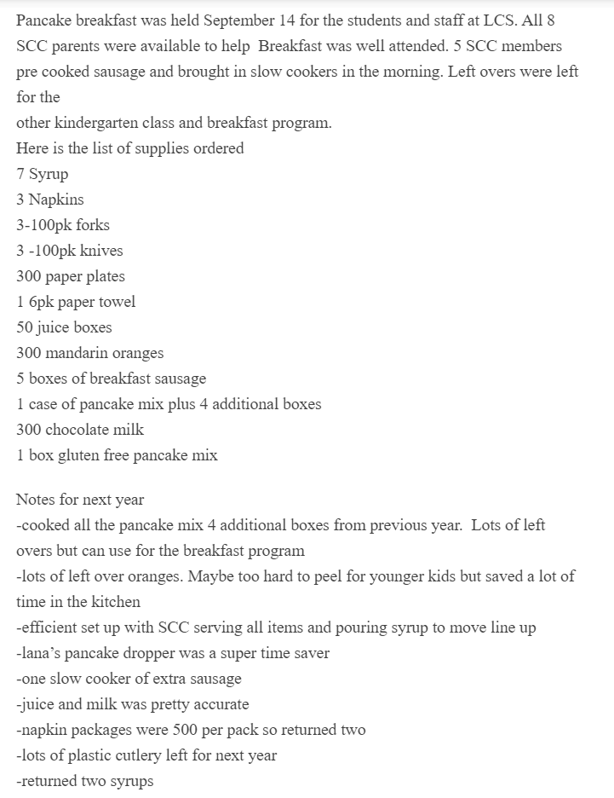

- Bulk School Supply Ordering
- Fallon spoke with Shawna Nerbas about bulk ordering from their supplier and she supported the idea.
- Fallon / Oralie have reached out to CPS to get more information on their process.
- Once this information is received, next step will be to send a survey out to gauge interest.
- Vaping Speaker
- Raelene will do some research to look into possible speakers to present the on the effects of vaping.
- Community Garden
- Candace is attending LCS staff meeting on November 7th to discuss plot plans for next year and a few ideas.
- A naming contest was held with the younger grades for the garden. “The Learn & Grown Community Garden” was selected. Great participation in the contest.
- The committee is looking into having a contest for the development of a logo for the older grades in the future.
- New Business:
- LCS School Level Plan (SLP)
- SLP was shared with SCC in advance of meeting for review and feedback.
- Kim W. motioned to move the SLP as presented. Jenay seconded / carried.
- Jill will sign off on SLP as SCC chair.
- LCS Open House-Babysitting Service
- Fallon will notify SCC if this service will be required this year. If open house is held (as noted in Principal’s report), this service will not likely be required.
- Noon Hour Supervision During STF Sanctions
- The division has requested that schools have a plan in place to ensure adequate coverage if sanctions take effect. An email was sent to SCC to seek interest in providing noon hour supervision for this purpose.
- High school students have expressed interest in this, so SCC / external resources may not be required.
- No further information is known at this time (timelines, etc.). Fallon and Oralie will keep SCC updated.
- 2023 Christmas Festivities
- Christmas events were covered in Principal’s report.
- 2023 / 2024 Meeting Dates:
- January 8, 2024
- March 11, 2024
- May 13, 2024
- September 6, 2024
- November 4, 2024 (Regular Meeting & AGM)

- Adjournment
Jill Faul adjourned the meeting at 8:26 PM.
Minutes submitted by: Mandi Kobylko
Minutes approved by:

